Weather Vane Anemometer

Subject: Math, Physics  Related Subjects:Mechanical Engineering | Grade Level(s):  Length of Lesson: | Type: Inquiry / Design / Project  Keywords:Wind Speed,Wind pressure, Aerospace Engineering

Lesson Overview
Use this section to describe at a high level what the lesson is. Should be no more than 3-4 lines.

Lesson Focus
What is the central question or phenomenon being investigated? What problem are they trying to solve?

Lesson Objective(s) | By the end of this lesson, students will…  - Learn the concepts of attraction, repulsion, friction, polarity, and charge.

Lesson Timing

5 minutes | Introduce the Lesson
30 minutes | ...

Materials | - Cups  - Push pins  - Card stock  - Scissors  - Pencils  - Paper clips  - Straws  - Tape  - Foam board
Instructor Prep | - Step 1
Related Resources | - List related lessons/ppts etc available from USC or outside, trusted orgs

Lesson Plan

Introduction
Introduce students to the learning goals and make connections to past and present learning experiences. Stimulate interest and prompt students to identify their own questions about the topic. This can link the lesson to real world examples, introduce associated STEM careers, and assess their prior knowledge on the topic.

- Step 1

Procedure
List the steps of the activity. Remember to focus on leading students to the solution, rather than just telling them what to do. Include pictures of steps if you have them. Be sure to include some steps for discussion and reflection.

Weather Vane

- Cut a 3” x 12” piece of board and divide it into a 3”x7” and a 3”x5”
- Tape 1 cup upside down on end of board of long board
- Write N, E, S,W 90 degrees apart on the end of the long board (for North, East, South and West)
- Push sharpened pencil through bottom of cup and remove
- Insert unsharpened pencil into holes
- Cut out a large triangle and a small triangle
- Insert a nail through straw about 2 fingers past the midpoint.
- Spin and maneuver straw until it spins freely.
- With the nail facing up to the ground, make about a ½“ incision on the long end and about a ¾“ incision on the short end.
- Insert the base of the small triangle into the ½“ incision and tape into place.
- Insert top of large triangle in to ¾” incision and tape into place.
- The triangles and pins should all line up.
- Insert straw with triangles into both

Anemometer

- – Tape the other cup down on the second board
- –Using pencil, punch one hole in the side of each of four of the 3oz cups.
- –Take the 5th 3oz up and:
  - punch 2 holes across from each other about ¼” from the bottom
  - punch 2 more holes across from each other, 90 degrees apart and ¼” above the first set of holes
  - punch a hole in the center of the bottom of the cup.
- –Insert straw through hole of one of the cups, fold the end of the straw and paperclip to the side of cup.
- –Insert 2nd straw through hole of another of the cups, fold the end of the straw and paperclip to the other side of cup across from the hole.
- –Slide 1 straw from straw/cup through opposite holes on four hole cup.
- –Insert straw/cup straw through hole of one of the free cups, fold the end of the straw about 1” and paperclip to the side of cup across making certain that the two cups face different directions when one faces you (see figure 2).
- – Slide straw from straw/cup through other opposite holes on four hole cup.
- – Insert remaining straw/cup straw through hole of remaining free cups, fold the end of the straw about” and paperclip to the side of cup making certain that the two cups face different directions when one faces you.
- –Align the four cups so that their open ends face the same direction clockwise or counterclockwise (see figure 3).
- –Push the pin through the two straws where they intersect.
- ––Attach cup structure to pencil by pushing it so pencil passes through hole in center cup.
- –Push pin in straws through eraser of pencils.
- –Mark one of the spinning cups.
- –Calculate the circumference of the circle created by cups of the anemometer in feet.
- –Tape pencils in place to keep them from wobbling
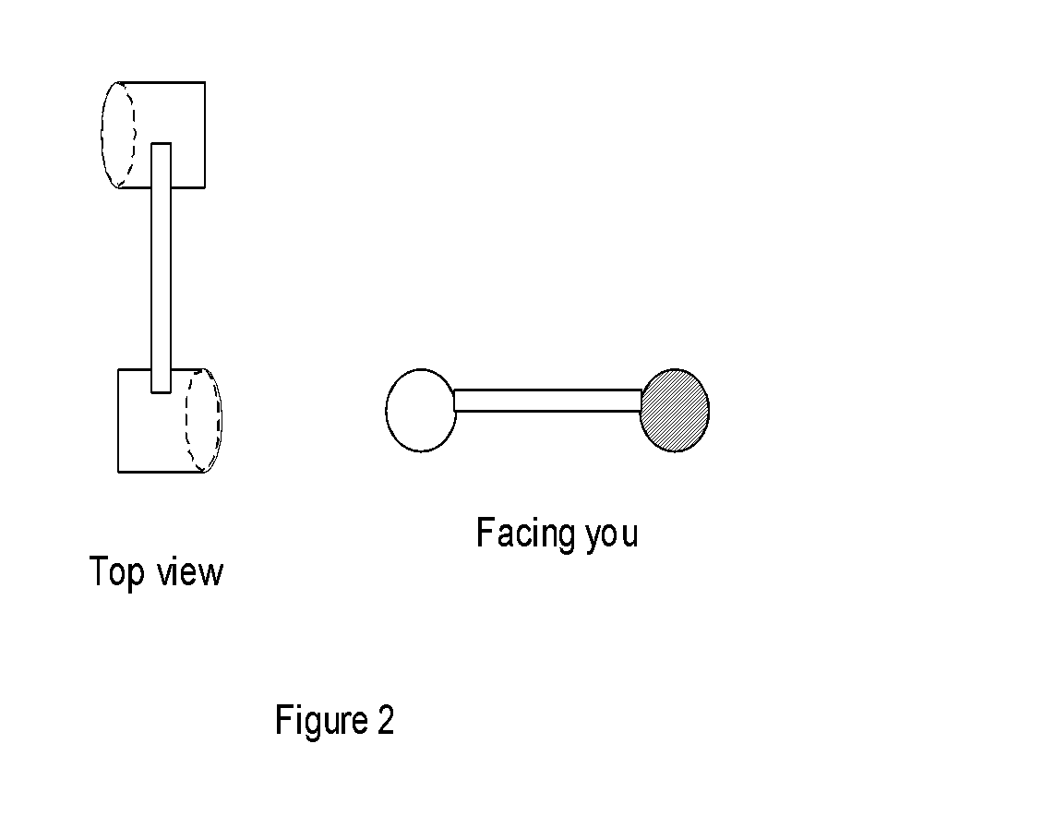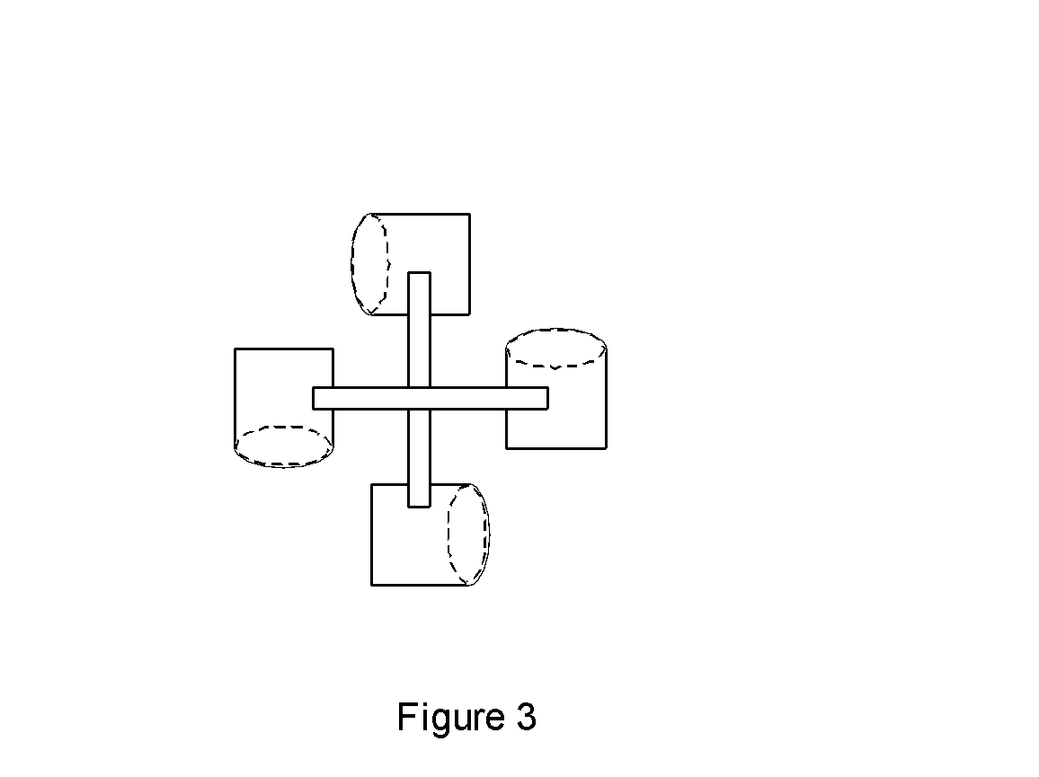

Wrap-up
End the lesson with some final discussions about what students designed/discovered. Connect their activity back to the focus question/problem, real world examples, and STEM careers.

Also include notes about any special cleanup considerations

Lesson Background for Teachers

Suggested Real-World STEM Connections
- List possible related Role Models in STEM (with details and links to more reading). Give suggestions for examples of scientists/engineers who are from underrepresented groups in STEM in related careers.
- List related real-world engineering problems and examples

Lesson Variations and Options
Include descriptions of alternative methods or ways to present things.

Explanation
Describe the background concepts and explanations behind the lesson. This can be more in depth than a teacher/instructor would actually share with students.

Key Concepts and Vocabulary
- Word 1: Grade Appropriate Definition
- Word 2: Grade Appropriate Definition

Safety Notes
- Safety instruction

